


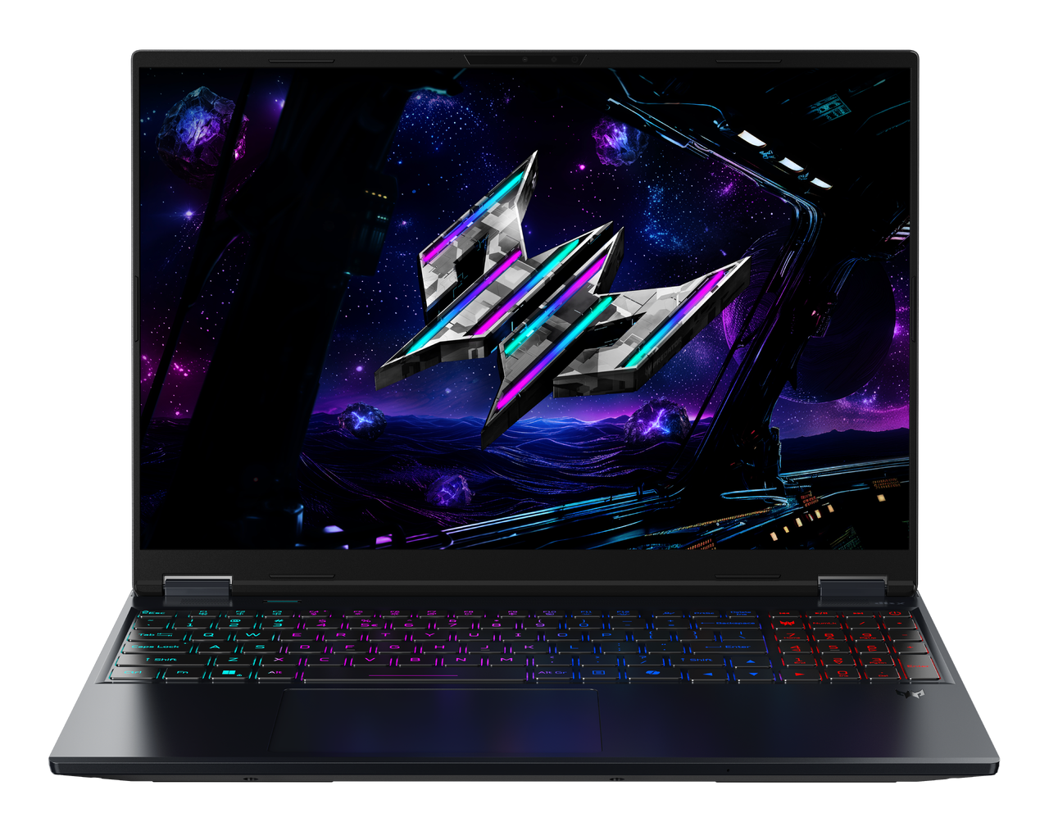

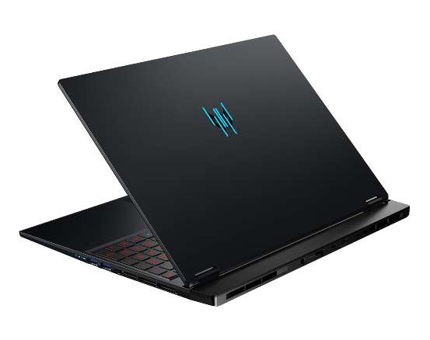
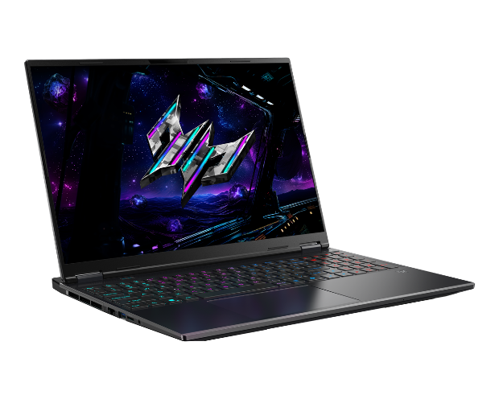
PREDATOR HELIOS NEO 16S AI

16
15
14
13
Product views | - Microphones  - FHD IR Webcam  - 16:10 Display  - Mode Key  - Ethernet (RJ-45) Port  - USB 3.2 Gen 1 Port  - MicroSD Card Reader | - Headset/speaker Jack  - Keyboard  - Touchpad (MS Precision Certified)  - Power Button  - PredatorSense key  - Battery Indicator  - Power Indicator |  |  |  | - USB 3.2 Gen 2 Port with Power-off Charging  - USB 3.2 Gen 2 Port  - Power Connector (DC-in)  - HDMI® 2.1 Port  - USB Type-C™ port (Thunderbolt™ 4)  - USB 3.2 Gen 2 Type C
Operating system¹ | Windows 11 Home
CPU and chipset¹ | Intel® Core™ Ultra 9 processor 386H |  |  | Intel® Core™ Ultra 7 processor 356H
Memory^{1, 2, 3} | Up to 64 Dual-channel DDR5 using two soDIMM Modules  Dual-channel DDR5 SDRAM Support |  |  | Memory Frequency: Up to 6400 MT/s
Display⁴ | 16.0" display with OLED (Organic Light-Emitting Diode) Technology,  WQXGA 2560 x 1600, high-brightness (500 nits, typical value) Acer CineCrystal™  - 16:10 Aspect Ratio, DCI-P3 100%  - Supports up to 165Hz  - NVIDIA Advanced Optimus Capable  - Wide Viewing Angle up to 178 Degrees  - Mercury Free, Environmentally Friendly
Graphics¹ | - NVIDIA® GeForce RTX™ 5070 with 8 GB of dedicated GDDR7 VRAM  - NVIDIA® GeForce RTX™ 5060 with 8 GB of dedicated GDDR7 VRAM
Audio | - DTS® X:Ultra Audio, featuring optimized Bass, Loudness, Speaker Protection with up to 6 custom content modes via smart amplifier  - Supported in Windows Spatial Sound for PC Gaming with DTS Sound Unbound license integrated  - Immersive audio rendering over headphones and internal speakers  - High SNR DAC with 2.1 Vrms out capability and can driver high impedance headphone (up to 600 ohm)  - Acer Purified.Voice technology with AI noise reduction in 3 mics array built-in microphones to support Advanced Privacy Mode. Features include far-field pickup, dynamic noise reduction through neural network, adaptive beam forming, and pre-defined personal and conference call modes.  - Soundwire Codec with MSFT SDCA 1.0 driver supported  - Compatible with Cortana with Voice  - Acer TrueHarmony Technology for lower distortion, wider frequency range, headphone-like audio and powerful sound  - Hi-Res Audio Certification by JAS ( Headphone Output setting supported up to 24bit /192KHz)
Storage | Solid state drive:  - 512 GB / 1 TB / PCIe Gen4, 16 Gb/s, NVMe
Webcam¹ | UFC with  - Narrow USB FHD camera + IR camera with blue glass  - 1920 x 1080 resolution Dual Mic |  |  | - Staggered High Dynamic Range (SHDR)  - 1080p video fps with Temporal Noise Reduction
Wireless and networking¹ | WLAN  - Killer Wireless Wi-Fi 6E 1675i  - 802.11 a/b/g/n/ac/ax wireless LAN  - Band: 2.4 GHz, 5 GHz and 6 GHz  - 2x2 MU-MIMO technology  - Support CNVi interface | LAN  - Killer™ Ethernet E3100G  - 2.5G Ethernet  - Killer Control Center  - Lag and Latency Reduction™ Technology  - Advanced Stream Detect™2.0 |  |  |  | - Killer DoubleShot™ Pro enabled  - GameFast™ Technology  WPAN  - Supports Bluetooth® 5.4 or above  - Supports Bluetooth LE Audio (LC3).
Security | Firmware Trusted Platform Module (TPM) solution |  | BIOS user, supervisor |  |  |  | Kensington lock slot
Dimensions and weight ^{6, 7} | Dimensions: • 356.78 (W) x 275.5 (D) x 12/18.9 (H) mm (14.05 x 10.85 x 0.47/0.74  inches)  Weight:  - 2.2 kg (4.85 lbs.) with 4-cell battery pack
Power adapter and battery⁸ | Power adapter:  - 92 Wh 4-cell Li-ion battery  - For models with OLED  - Battery life:  - Up to 6 hours (based on MobileMark® 2030 test results)  - Up to 15 hours (based on video playback test results) |  |  | Battery:  - 92 Wh 4-cell Li-ion battery  - For models with OLED  - Battery life:  - Up to 6 hours (based on MobileMark® 2030 test results)  - Up to 15 hours (based on video playback test results)
Input and control | Keyboard:  103(US)-/104(UK)-key, FineTip RGB-backlight keyboard with independent standard numeric keypad, international language support  • 1.5mm travel distance keyboard, Programmable key design : Acer My Key, Microsoft Copilot key design, Individual key of Predator Sense app enabling, Indicators of CapsLock and Microphone mute toggle indicators, Function Lock design  Touchpad: Multi-gesture touchpad, supporting two-finger scroll; pinch; gestures to open Cortana, Action Center, multitasking; application  commands  - Microsoft Precision Touchpad certification  - Moisture resistant  Control Keys  Mode Key, PredatorSense Key, Copilot Key
Windows Desktop Apps¹⁰ | In-House  - Acer LiveArt  - PredatorSense V5 |  |  | - Acer QuickPanel  - Acer VisionArt |  |  |  | Tools  - Acer My Key Application
Warranty | One-year International Travelers Warranty (ITW)
- Specifications vary depending on model.
- Shared system memory may be allocated to support graphics, depending on system memory size and other factors. Actual system memory available to the operating system will be reduced by any memory used by the graphics solution and resources required by the operating environment.
- Memory speed may vary, depending on the CPU, chipset or memory fitted.
- All brands and product names mentioned herein include trademarks of their respective companies and are used solely to describe or identify the products.
- 1 GB is 1 billion bytes. Actual formatted capacity is less and may vary depending on preloaded materials and operating environment. Acer Recovery Management uses a portion of the stated hard disk capacity as dedicated backup space.
- Minor variations in system dimensions are possible due to the manufacturing process.
- Weight may vary depending on product configuration, vendor components, manufacturing variability, and selected options.
- Listed battery life is based on testing using video playback. The test clip loops and continues to run, without interruption or any other inputs, until the battery is drained. Stated battery life is for comparison purpose only. Actual battery life varies by model, configuration, applications, video chip format and features used. A battery's maximum capacity decreases with time and use. Battery life test configuration: 14th Gen Intel® Core™ i9, NVIDIA® GeForce RTX™ 4090, WQXGA, Dual SSD, 64GB of DDR5 memory. Battery life test condition: LCD brightness 150 nits, connected headphones, WLAN off, Bluetooth off and Better Battery Mode on.
- Actual battery life may vary considerably by specifications, depending on product model, configuration, applications, power management settings, operating conditions, and features utilized. Performance variation also arises based on components in use, which includes but is not limited to the processor, RAM capacity, storage, display and resolution, etc.
- Bundled software may vary depending on hardware configuration, OS and regional availability.
Note: This specification is based on Predator PHN16S-I51 Specifications (v7-0-7) (Preview)
1
20
19
18
17
11
12
9
10
8
7
6
5
4
3
2
1
SPECIFICATIONS PREDATOR HELIOS NEO 16S AI PHN16S-I51

